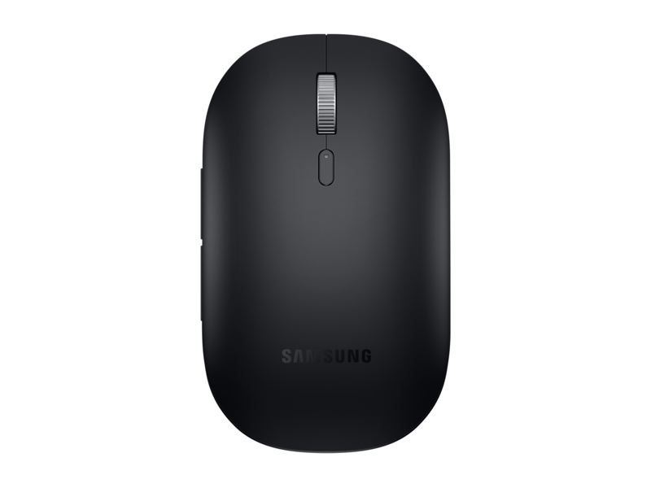

**Bluetooth Mouse Slim, Black**

**EJ-M3400DBEGUS**

1.7 out of 5 stars, average rating value. Read 6 Reviews. Same page link.

1.7

(6)

Write a review

Share your product experience

* for Business
* Samsung Easy pairing.  
  High responsiveness & precise tracking.

**Choose Color**

**[Black](https://www.samsung.com/us/business/computing/computing-accessories/computers/bluetooth-mouse-slim--black-ej-m3400dbegus/" \t "_self)**

**[Silver](https://www.samsung.com/us/business/computing/computing-accessories/computers/bluetooth-mouse-slim--silver-ej-m3400dsegus/" \t "_self)**

**Delivery Details**

Free shipping and easy returns: Ship to **10001**(change)

Get it by: **Dec 18, 2024**

**Quantity**

**-1+**

SAVE WITH BUSINESS BULK DISCOUNT PRICING

[](https://www.samsung.com/us/business/account/login/)

Don't have a Samsung Business Account? Sign up and get an extra 5% off your first order of this product.[**SIGN UP NOW >**](https://www.samsung.com/us/business/account/login/?phase=signup)

**Bluetooth Mouse Slim, Black**

Quantity: 1**$59.99**

Total

**$59.99**

[**Buy Now**](javascript:;)

Supported payment types:Visa, American Express, Discover, MasterCard, Drivers Club, JCB, Amazon Pay, Paypal, Samsung Business Financing



Exclusive deals

Volume discounts

Flexible Financing

Convenient shipping

**Samsung Business Account**

Get exclusive deals, volume pricing, free shipping and flexible financing on a wide range of Samsung technology for your business.

[**SIGN UP**](https://www.samsung.com/us/business/account/login/)

**Comfort for wherever you work**

Portable and elegant, the Bluetooth Mouse Slim lets you set up and get to work with all-day comfort. The sculpted design supports your hand for a good grip, and it's slim enough to slip into your laptop bag so you can keep it on hand.